|  |  |
| --- | --- |
| Jacksonville, FL | LolaJamesBadz@gmail.com |

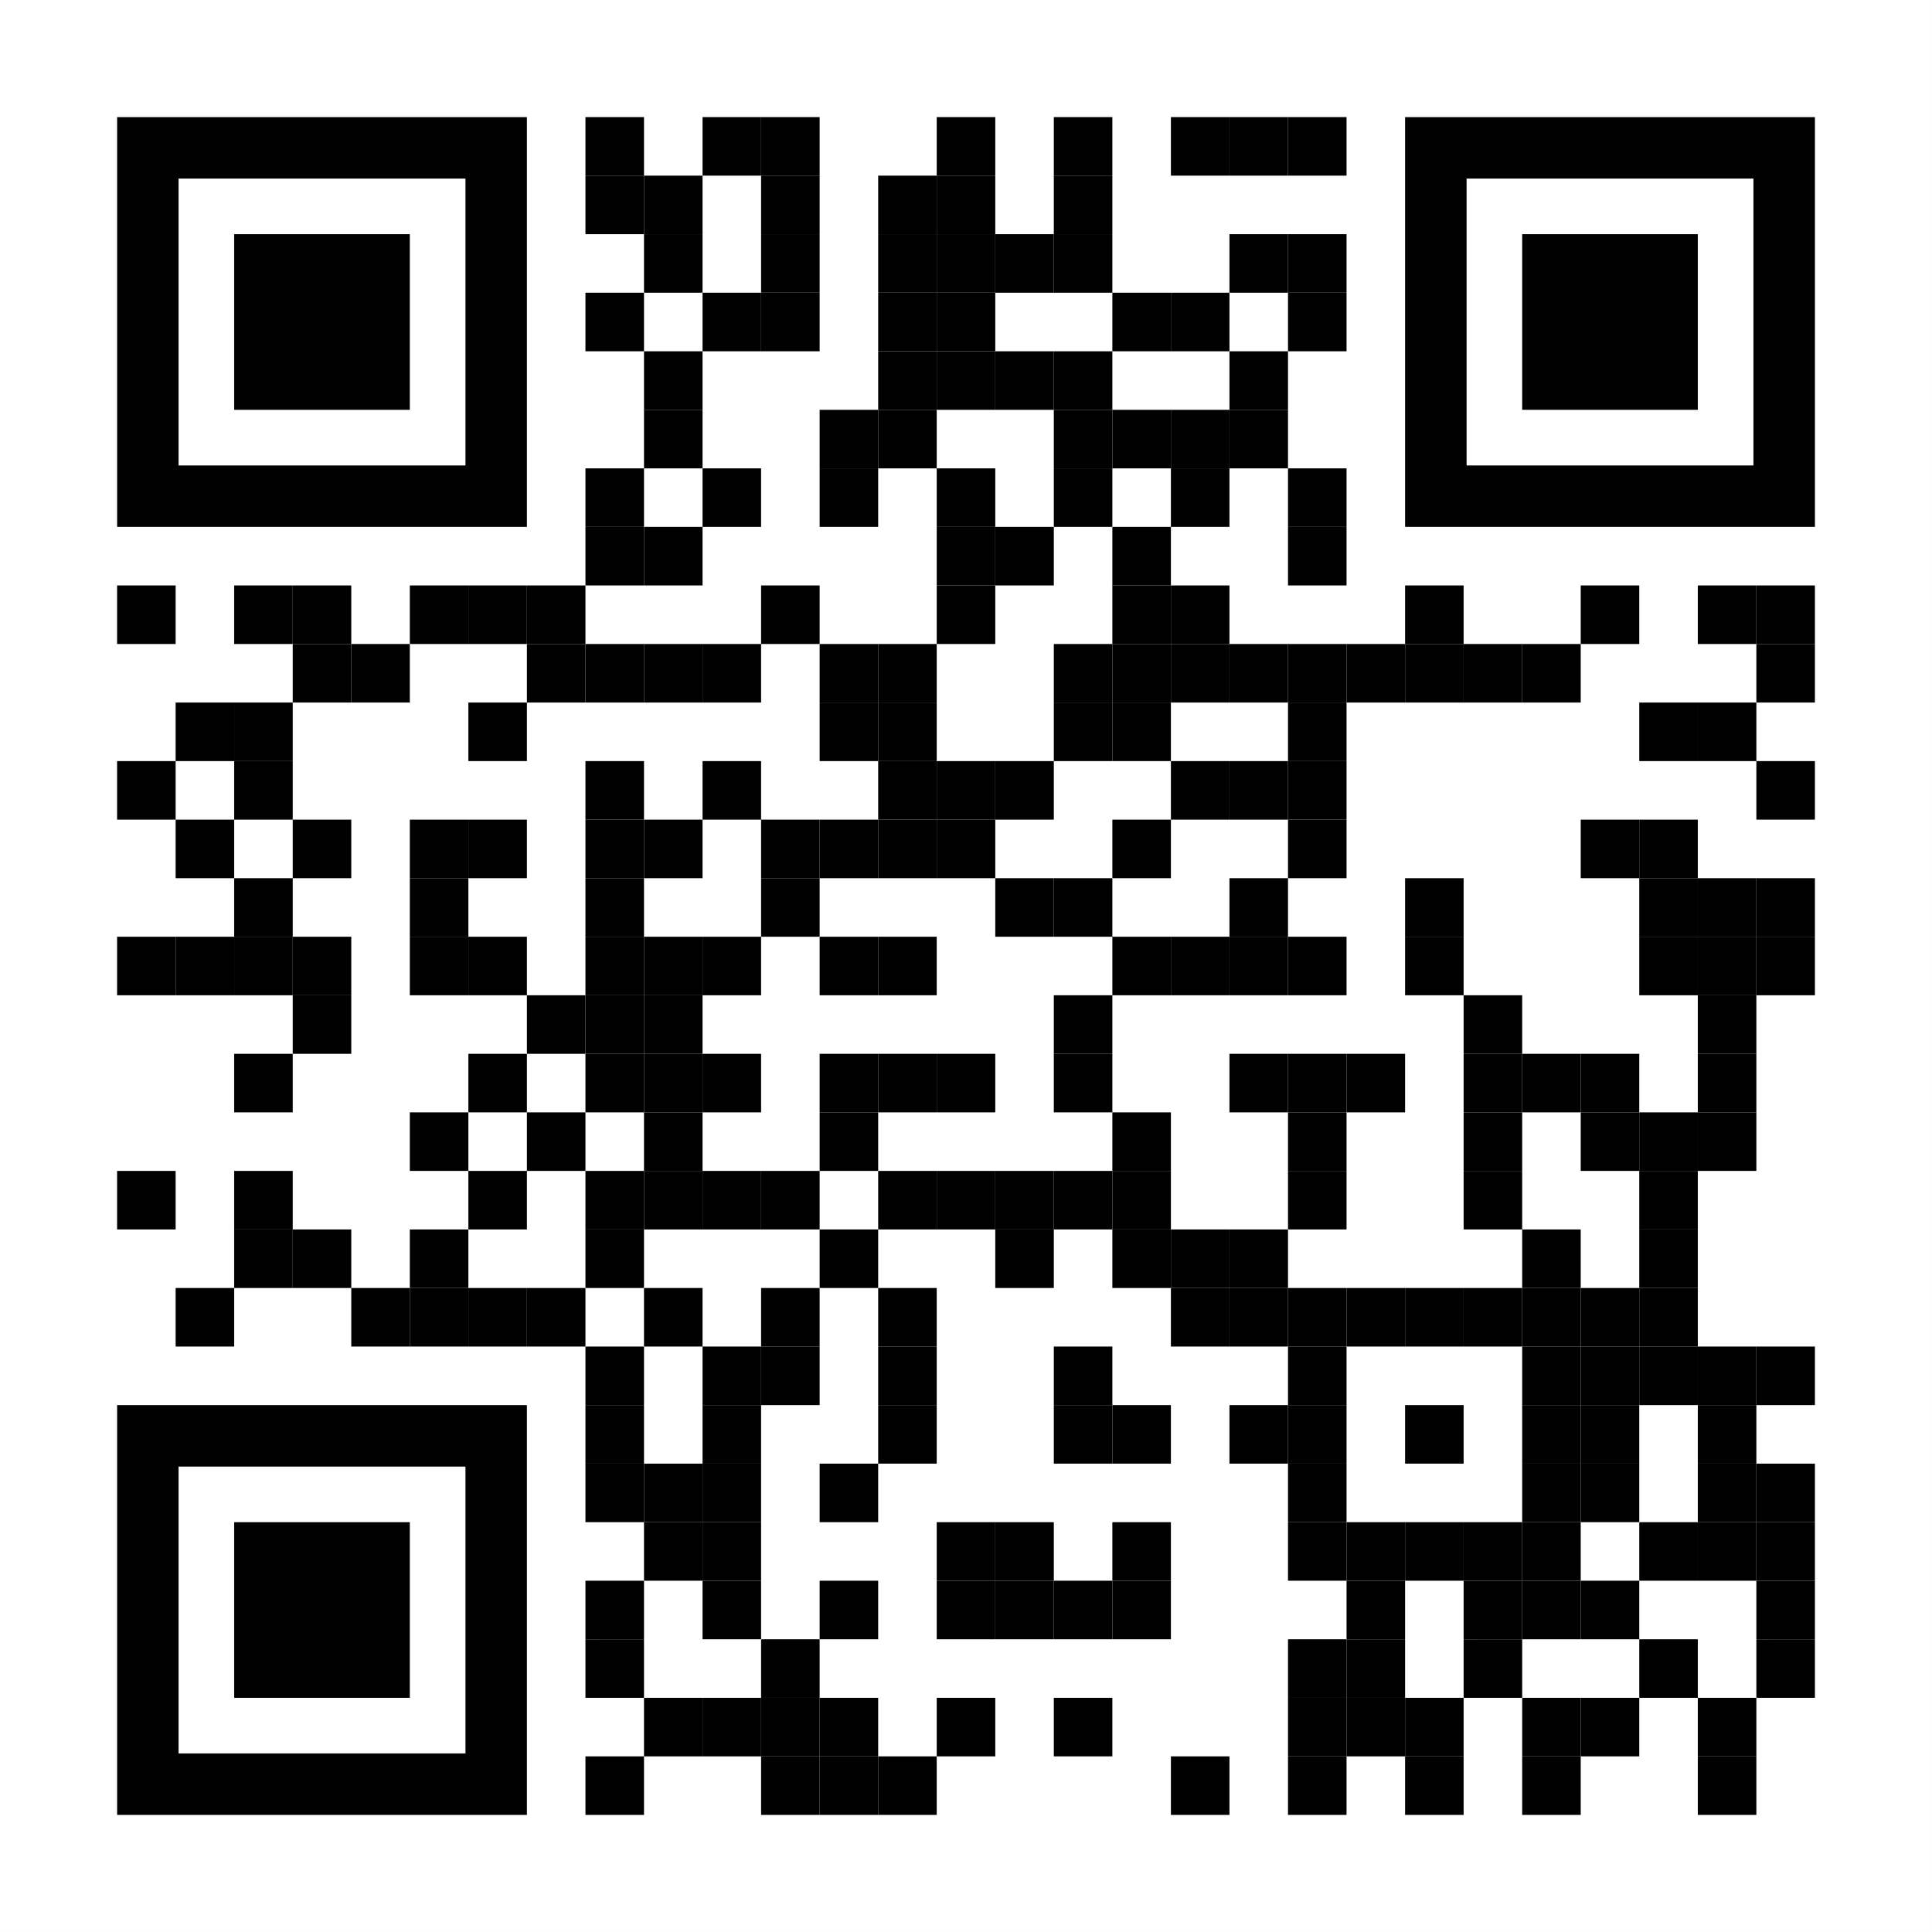

Lola Badz

# College student

# Linkdin

<https://www.linkedin.com/in/lola-badz-481a13315/>

|  |  |
| --- | --- |
| Education Florida State College at Jacksonville  501 State St W, Jacksonville, FL 32202  Computer Information Technology  Graduate of Atlantic Coast Highschool | Functional Skills Microsoft Applications  Mastered essay structure  Development of strong writing skills  Processes of troubleshooting user problems  Technical assistance  System upgrades and services  Customer service  Studied major historical events  Analyzed the influence of government  Critical thinking and analytical skills  Computer Hardware comfortability |
|  | Experience November 2021 - present  Food Server • Hong Kong Bistro    September 2022 – December 2022  Cashier/Food Service• Jon Smith Subs    November 2024 – January 2025  Baker/Barista • Cheesecake Factory |
|  | IT related experience Computer Information Technology – Class – ACHS  Computer Science – Class – ACHS  Unity Engine – Class – ACHS  Computer building – Self learning  Computer Maintenance – Self Learning  Game Design – Class – ACHS |
|  |  |